

Universal Characteristic Method of Human Profiling (Pythagoras Character Development Theory)

## Archetype compass

Career, Business, Relationship and Family Success.

###### Name :

## THE ARCHETYPE PROCESSOR

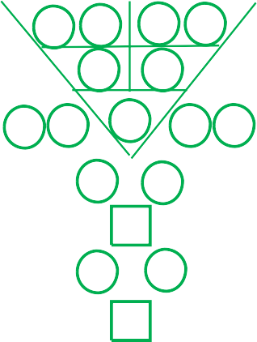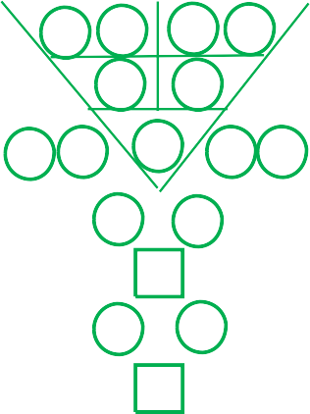

**Mr Kiran Shetty**

**Date of Birth** : **0 8** - **0 3** - **2 0 2 2**

**Time of Birth** : **1 8 : 3 4**

**Gender** :

**Twins or Triplets** :

**Male**

**No**

**Report prepared by** : **sessiontester**

**Date of Prepared : 8 – 3 – 2022**

|  |  |  |  |  |
| --- | --- | --- | --- | --- |
|  |  |  |  |  |
| Date of Birth |  |  |  | Time of Birth |

3

6

|  |  |  |  |  |  |  |  |  |  |
| --- | --- | --- | --- | --- | --- | --- | --- | --- | --- |
| 0 | 8 | 0 3 | | | 2 | | 0 | 2 | 2 |
|  | | | | | | | | | |
|  | 8 | | 3 |  | | 2 | 4 | |  |
|  |  | | 2 |  | | 6 |  | |  |
| 1 | 5 | |  | 8 | |  | 8 | | 1 |
| 5 | | | |  | | 1 | | | |
|  | | | | 6 | |  | | | |
| 7 | | | |  | | 2 | | | |
|  | | | | 9 | |  | | | |

9

6

|  |  |  |  |  |  |  |  |  |  |
| --- | --- | --- | --- | --- | --- | --- | --- | --- | --- |
| 0 | 8 | 0 3 | | | 1 8 | | | 3 | 4 |
|  | | | | | | | | | |
|  | 8 | | 3 |  | | 9 | 7 | |  |
|  |  | | 2 |  | | 7 |  | |  |
| 1 | 5 | |  | 9 | |  | 7 | | 5 |
| 7 | | | |  | | 2 | | | |
|  | | | | 9 | |  | | | |
| 2 | | | |  | | 7 | | | |
|  | | | | 9 | |  | | | |

Destiny Number

|  |
| --- |
| **8 3 2 4** |
| **8** |
| **6** |
| **2** |
| **8 1** |
| **1 5** |
| **5** |
| **2** |
| **1 2 4 3 7** |
| **4 2 9 7** |

Universal Character Archetype Personality Strength Number Personality Weakness Number Whole Life Inborn Strength Number

Whole Life Inborn Challenge Number Hidden Potential Number - Intuition Hidden Potential Number - Blind Spot Your Hidden Talents Number

Your Life Code

|  |  |  |  |  |  |  |  |  |  |  |  |  |  |  |  |  |  |
| --- | --- | --- | --- | --- | --- | --- | --- | --- | --- | --- | --- | --- | --- | --- | --- | --- | --- |
|  | **49 Steps To Know Your True Self** | | | | | | | | | | | | | | | |  |
|  | | | | | | | | | | | | | | | |
|  | 1 | **8** | 8 | **4 6** | 15 | **8 1** | 22 | **3 2** | 29 | **8 8** | 36 | **1 2** | 43 | **4 8** |  |
| 2 | **8 3** | 9 | **6** | 16 | **2 6** | 23 | **2 5** | 30 | **4 2** | 37 | **8 8** | 44 | **6 7** |
| 3 | **2 4** | 10 | **6 8** | 17 | **6 8** | 24 | **2 1** | 31 | **6 1** | 38 | **8 6** | 45 | **6 2** |
| 4 | **2 6** | 11 | **8 5** | 18 | **6 1 2** | 25 | **5 5** | 32 | **1 5** | 39 | **3 6** | 46 | **7 9** |
| 5 | **1 5** | 12 | **8 2** | 19 | **8 1** | 26 | **1 5** | 33 | **8 2** | 40 | **3 8** | 47 | **2 9** |
| 6 | **8 1** | 13 | **2** | 20 | **1 1** | 27 | **5 6** | 34 | **8 4** | 41 | **2 2** | 48 | **8 6** |
| 7 | **5 1** | 14 | **2 8** | 21 | **1 6** | 28 | **5 8** | 35 | **3 1** | 42 | **2 8** | 49 | **6 9** |
|  | | | | | | | | | | | | | | | |

**About Kiran Shetty**



**Dear Kiran Shetty**

8

To understand yourself is the beginning of wisdom.

###### You are Disciplinarian, Auditory and Operational Taskmaster

You are a disciplined, responsible, committed person, task oriented and can be in charge of the paperwork and projects. A hardworking workaholic who can go the extra mile to do things if necessary.

**Your physical environment, describe you are: Characteristically Introvert & Socially Introvert**

You are inward turning, or focused more on internal thoughts, feelings and moods rather than seeking out external stimulation. You tend to be more quiet, reserved, and introspective. You expend energy in social situations; after attending a party or spending time in a large group of people, you feel a need to “recharge” by spending a period of time alone.

###### To describe you the best, you are : A Pragmatist

You are organised, structured, practical and goal-oriented. You are straight-forward and rely on facts and logic. You act in response to particular situations rather than upon abstract ideals and fixed theories. On the down side, you can be inflexible, rigid and dogmatic. To you seeing is believing.

###### Your Hidden Potential - "Blind Spot" :

###### You are probably not aware that you  are a dominant & expressive communicator with good negotiation skills. You are very much Intune to your emotions, Soft-hearted to most situations, and a sensitive person. You possess a keen sense of taste.

###### Your Hidden Potential - "Intuition" :

You are a principled and grounded architect, developer and builder. Recognised as a filial child and loyal friend. Gives others an impression of steadiness, with a good sense of direction.



|  |  |  |  |
| --- | --- | --- | --- |
| **Interpretation of missing or excessive code for Kiran Shetty** | | | |
| **Number** | **Description** | **Quantity** | **Status** |
| 1 | Leadership quality, independent, influential, charismatic, innovative, interpersonal skills. | **I ( 1 )** | **OK** |
| 2 | Diplomacy in communication and good in negotiation. | **III ( 3 )** | **EXCESSIVE** |
| 3 | Fast & aggressive, task-oriented, good Listener, operational. | **II ( 2 )** | **OK** |
| 4 | Strategising, administration work, conscientious, compliance. | **II ( 2 )** | **OK** |
| 5 | Good sense of direction, constructive, building ideas and concepts, principled, grounded. | **( 0 )** | **MISSING** |
| 6 | Family-oriented, protector, charismatic, influential, interpersonal skills. | **I ( 1 )** | **OK** |
| 7 | Lucky, enterprising, dominance, troubleshooter, multi-tasking, problem solving, good in negotiation. | **I ( 1 )** | **OK** |
| 8 | Survivor, responsible, judgemental, disciplined, workaholic. | **II ( 2 )** | **OK** |
| 9 | Creative, good foresight, forward looking, creative, business minded, good in packaging. | **( 0 )** | **MISSING** |
|  | | | |



**Colours**

**Shapes**



**to find the supporting & controlling role for Kiran Shetty (intergrating with PCDT, nlp, disc-o and eq)**

**Choices**

**UCA**

### Number

1 & 6

**Senses**

Touch (Hand)

**NLP**

### DISC-O EQ

Relationship Management

(I)

Influential Interpersonal

Kinaesthetic

Gold, Silver, White

**1st Choice**

You Can Control

4 & 9

See (Eye)

Social Awareness

Self Awareness

Self Motivation

Self Management

(S)

Social Operational

(C) Conscientious Compliance

(D) Dominant

(S)

Steady Steadfast

Auditory

Visual

Green

### 2nd Choice

Support You

### 3rd Choice

Neutral

### 4th Choice

You Support

### 5th Choice

Control You

#### 3 & 8

Smell (Nose)

5

Black, Dark Blue

Talk (Mouth)

#### 2 & 7

Red, Orange, Purple, Pink

Listen (Ear)

Gustatory

Olfactory

Yellow, Brown, Beige

**Suggestion of life code card design**

# 4 2 9 7 4 2 9 7

**4 2 9 7**



|  |  |
| --- | --- |
| **The supporting & controlling career choice For Kiran Shetty** | |
| 2 & 7  **1st Choice**  You Can Control | Accountant, Automotive Dealer, Bank Related, Electric Appliance, Exercise Equipment, Financial Institution, Financial Workforce, Government Office, Internet Security, Jewelry Dealer, Legal Profession, Machinery, Mechanical Engineering, Mining Minerals, Pawnshop, Police Enforcement, Politics, Science and Research Centre, Security Guard, Transportation |
| 3 & 8  **2nd Choice**  Support You | Artist, Author, Chinese Medicine, Design Studio, Doctor, Education, Fashion Designer, Forecasting, Furniture, Horticulture, Hospital, Human Culture, homeopathy, Interior designer, Library, Physiology, Pharmacy, Planting, Priest, Professor, Public Hygiene Officer, Publisher, Religion, Sawmill, Secretary (Admin), Teacher, Woodcraft |
| 5  **3rd Choice**  Your Own Number | Advertising, Air Freight, Branding, Canteen Operator, Chemical and Oil, Computer hardware, Cosmetic Products, Departmental Store, Fast Food, Fuel Related, Hot Drinks, Lighting, Magazine, Manpower Supply, Movie Maker, Nurse, Procurement with trading, Wholesaler |
| 1 & 6  **4th Choice**  You Support | Accounting Business, Antique Shop, Architect, Charity, Church, Contractor, Feng Shui Master, Fortune-teller, Funeral, Gardener, Gemstone, hypnotherapy, Marble, Mining, Numerologist, Pottery, Psychology, Psychotherapy, Real Estate, Shares and Security Broker, Universal Human Profiling |
| 4 & 9  **5th Choice**  Control You | Culture Show, Diplomat, Drink Vendor, Fisherman, Freelancer, Hawker, Insurance Agency, Internet Business, Magician, Maid Agency, Mathematician, Money Changer, Newscaster, Postman, Radio Station, Reporter, Salesman, Seafood Supplier, Service Base Business, Shipping Services, Trading Services, Travel Agency, Vehicle's Driver |
|  | |

|  |  |  |  |  |
| --- | --- | --- | --- | --- |
| **Personal health check for Kiran Shetty** | | | | |
| **Main Body Parts** | | **Quantity** | **Status** | |
| **Lungs** | Lung/large intestine problems, Asthma, Skin allergies problems, Hay fever. | **II ( 2 )** | **OK** | |
| **Kidney** | Kidney/bladder problems, Fear/phobias, Low back pain, Sciatica, Frequent urination, Dark shadow/bags under the eyes, Disorders of the central nervous system, Aversion to cold, Impotence/frigidity | **I ( 1 )** | **OK** | |
| **Heart** | Heart/small intestine problems, Cardiovascular diseases, Insomnia, Restlessness, Forgetfulness, Speech disorders, Depressed, Pain in chest region, Hypersensitive. | **I ( 1 )** | **OK** | |
| **Liver** | Liver/Gallbladder problems, Anger/complete absence, Impatient/easily frustrated, Eye problems, Problems with equilibrium/coordination, Muscle cramps, Lack of flexibility/stiffness, Bitter taste in mouth, Irregular menses, Tendon problems. | **( 0 )** | **MISSING** | |
| **Stomach** | Stomach/pancreas/spleen problems, Immune system problem, Digestive problems, Belching, Lack of absorption, Loose Bowels, Anaemia, Haemorrhoids, Overweight or under weight, Inability to receive nutrient, Lymphatic problems. | **I ( 1 )** | **OK** | |
|  | | | | No |
| Yes |
|  |

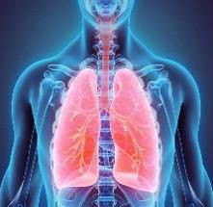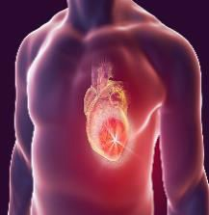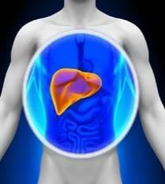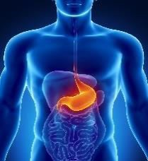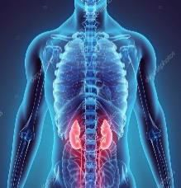

Potential Heart Bypass : Yes

Potential Heart Attack : Yes

Potential Cancer : Yes

#### Potential Hereditary Diseases :

Potential Cervical/Prostate Issue :

**9 years world outlook for Kiran Shetty**

**Year**

**Year**

**Year**

6

6

9

6

3

6

|  |  |  |  |  |  |  |  |  |  |
| --- | --- | --- | --- | --- | --- | --- | --- | --- | --- |
|  | |  | | | 2 | | 0 | 2 | 2 |
| 0 | 8 | 0 3 | | |  | | |  | |
|  | 8 | | 3 |  | | 2 | 4 | |  |
|  |  | | 2 |  | | 6 |  | |  |
| 1 | 5 | |  | 8 | |  | 8 | | 1 |
| 5 | | | |  | | 1 | | | |
|  | | | | 6 | |  | | | |
| 7 | | | |  | | 2 | | | |
|  | | | | 9 | |  | | | |
|  | | | | | | | | | |

|  |  |  |  |  |  |  |  |  |  |
| --- | --- | --- | --- | --- | --- | --- | --- | --- | --- |
|  | |  | | | 2 | | 0 | 2 | 3 |
| 0 | 8 | 0 3 | | |  | | |  | |
|  | 8 | | 3 |  | | 2 | 5 | |  |
|  |  | | 2 |  | | 7 |  | |  |
| 1 | 5 | |  | 9 | |  | 9 | | 3 |
| 7 | | | |  | | 2 | | | |
|  | | | | 9 | |  | | | |
| 2 | | | |  | | 7 | | | |
|  | | | | 9 | |  | | | |
|  | | | | | | | | | |

|  |  |  |  |  |  |  |  |  |  |
| --- | --- | --- | --- | --- | --- | --- | --- | --- | --- |
|  | |  | | | 2 0 | | | 2 | 4 |
| 0 | 8 | 0 3 | | |  | | |  | |
|  | 8 | | 3 |  | | 2 | 6 | |  |
|  |  | | 2 |  | | 8 |  | |  |
| 1 | 5 | |  | 1 | |  | 1 | | 5 |
|  |  | | 9 |  | | 3 |  | |  |
|  |  | |  | 3 | |  |  | |  |
|  |  | | 6 |  | | 3 |  | |  |
|  |  | |  | 9 | |  |  | |  |
|  | | | | | | | | | |

**Year**

**Year**

**Year**

6

6

9

6

3

6

|  |  |  |  |  |  |  |  |  |  |
| --- | --- | --- | --- | --- | --- | --- | --- | --- | --- |
|  | |  | | | 2 | | 0 | 2 | 5 |
| 0 | 8 | 0 3 | | |  | | |  | |
|  | 8 | | 3 |  | | 2 | 7 | |  |
|  |  | | 2 |  | | 9 |  | |  |
| 1 | 5 | |  | 2 | |  | 2 | | 7 |
| 2 | | | |  | | 4 | | | |
|  | | | | 6 | |  | | | |
| 1 | | | |  | | 8 | | | |
|  | | | | 9 | |  | | | |
|  | | | | | | | | | |

|  |  |  |  |  |  |  |  |  |  |
| --- | --- | --- | --- | --- | --- | --- | --- | --- | --- |
|  | |  | | | 2 | | 0 | 2 | 6 |
| 0 | 8 | 0 3 | | |  | | |  | |
|  | 8 | | 3 |  | | 2 | 8 | |  |
|  |  | | 2 |  | | 1 |  | |  |
| 1 | 5 | |  | 3 | |  | 3 | | 9 |
| 4 | | | |  | | 5 | | | |
|  | | | | 9 | |  | | | |
| 5 | | | |  | | 4 | | | |
|  | | | | 9 | |  | | | |
|  | | | | | | | | | |

|  |  |  |  |  |  |  |  |  |  |
| --- | --- | --- | --- | --- | --- | --- | --- | --- | --- |
|  | |  | | | 2 0 | | | 2 | 7 |
| 0 | 8 | 0 3 | | |  | | |  | |
|  | 8 | | 3 |  | | 2 | 9 | |  |
|  |  | | 2 |  | | 2 |  | |  |
| 1 | 5 | |  | 4 | |  | 4 | | 2 |
|  |  | | 6 |  | | 6 |  | |  |
|  |  | |  | 3 | |  |  | |  |
|  |  | | 9 |  | | 9 |  | |  |
|  |  | |  | 9 | |  |  | |  |
|  | | | | | | | | | |

**Year**

**Year**

**Year**

**2 0 3 0**

**2 0 2 9**

**2 0 2 8**

**2 0 2 7**

**2 0 2 6**

**2 0 2 5**

**2 0 2 4**

**2 0 2 3**

**2 0 2 2**

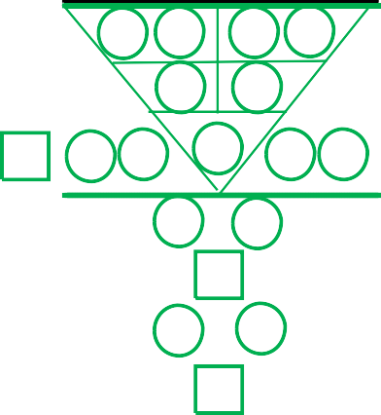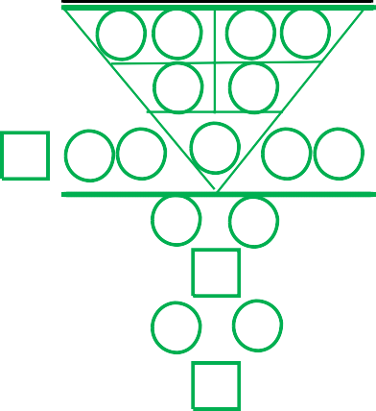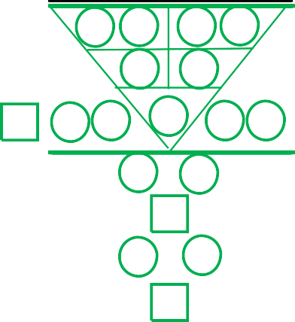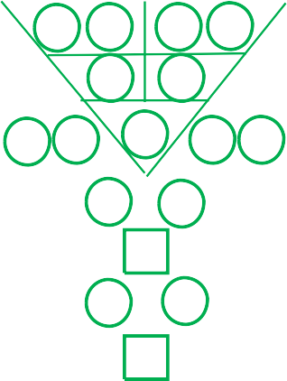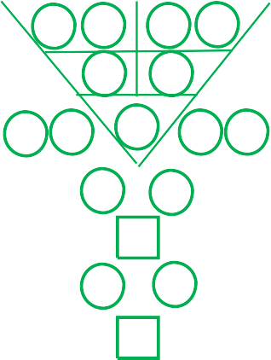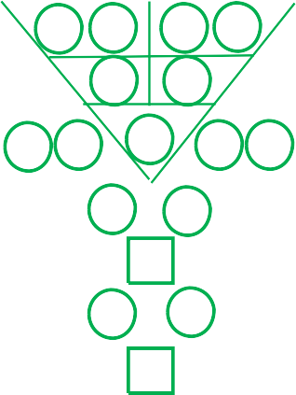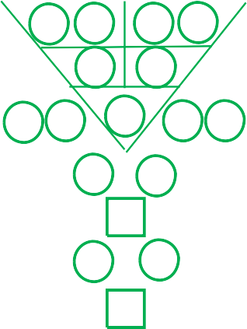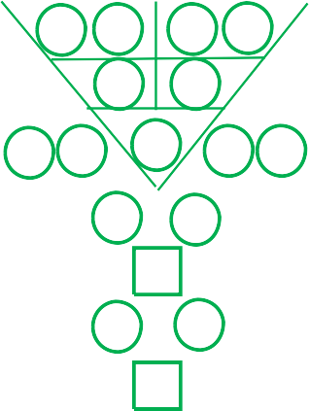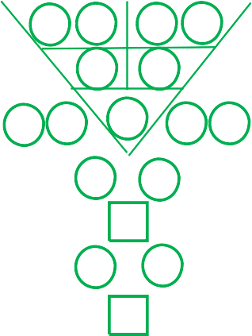

6

6

9

6

3

6

|  |  |  |  |  |  |  |  |  |  |
| --- | --- | --- | --- | --- | --- | --- | --- | --- | --- |
|  | |  | | | 2 | | 0 | 2 | 8 |
| 0 | 8 | 0 3 | | |  | | |  | |
|  | 8 | | 3 |  | | 2 | 1 | |  |
|  |  | | 2 |  | | 3 |  | |  |
| 1 | 5 | |  | 5 | |  | 5 | | 4 |
| 8 | | | |  | | 7 | | | |
|  | | | | 6 | |  | | | |
| 4 | | | |  | | 5 | | | |
|  | | | | 9 | |  | | | |
|  | | | | | | | | | |

|  |  |  |  |  |  |  |  |  |  |
| --- | --- | --- | --- | --- | --- | --- | --- | --- | --- |
|  | |  | | | 2 | | 0 | 2 | 9 |
| 0 | 8 | 0 3 | | |  | | |  | |
|  | 8 | | 3 |  | | 2 | 2 | |  |
|  |  | | 2 |  | | 4 |  | |  |
| 1 | 5 | |  | 6 | |  | 6 | | 6 |
| 1 | | | |  | | 8 | | | |
|  | | | | 9 | |  | | | |
| 8 | | | |  | | 1 | | | |
|  | | | | 9 | |  | | | |
|  | | | | | | | | | |

|  |  |  |  |  |  |  |  |  |  |
| --- | --- | --- | --- | --- | --- | --- | --- | --- | --- |
|  | |  | | | 2 0 | | | 3 | 0 |
| 0 | 8 | 0 3 | | |  | | |  | |
|  | 8 | | 3 |  | | 2 | 3 | |  |
|  |  | | 2 |  | | 5 |  | |  |
| 1 | 5 | |  | 7 | |  | 7 | | 8 |
|  |  | | 3 |  | | 9 |  | |  |
|  |  | |  | 3 | |  |  | |  |
|  |  | | 3 |  | | 6 |  | |  |
|  |  | |  | 9 | |  |  | |  |
|  | | | | | | | | | |

**2022 monthly world's outlook for Kiran Shetty**

**Year Year Year**

**2 0 2 2**

**2 0 2 2**

**2 0 2 2**

**2 0 2 2**

**2 0 2 2**

**2 0 2 2**

**2 0 2 2**

**2 0 2 2**

**2 0 2 2**

**Mar & Dec**

**Feb & Nov**

**Jan & Oct**

|  |  |  |  |  |  |  |  |  |  |
| --- | --- | --- | --- | --- | --- | --- | --- | --- | --- |
|  | | 0 1 | | | 2 | | 0 | 2 | 2 |
| 0 | 8 | 0 3 | | |  | | |  | |
|  | 8 | | 4 |  | | 2 | 4 | |  |
|  |  | | 3 |  | | 6 |  | |  |
| 2 | 7 | |  | 9 | |  | 8 | | 1 |
| 6 | | | |  | | 3 | | | |
|  | | | | 9 | |  | | | |
| 3 | | | |  | | 6 | | | |
|  | | | | 9 | |  | | | |
|  | | | | | | | | | |

|  |  |  |  |  |  |  |  |  |  |
| --- | --- | --- | --- | --- | --- | --- | --- | --- | --- |
|  | | 0 2 | | | 2 | | 0 | 2 | 2 |
| 0 | 8 | 0 3 | | |  | | |  | |
|  | 8 | | 5 |  | | 2 | 4 | |  |
|  |  | | 4 |  | | 6 |  | |  |
| 3 | 9 | |  | 1 | |  | 8 | | 1 |
| 7 | | | |  | | 5 | | | |
|  | | | | 3 | |  | | | |
| 8 | | | |  | | 1 | | | |
|  | | | | 9 | |  | | | |
|  | | | | | | | | | |

|  |  |  |  |  |  |  |  |  |  |
| --- | --- | --- | --- | --- | --- | --- | --- | --- | --- |
|  | | 0 3 | | | 2 0 | | | 2 | 2 |
| 0 | 8 | 0 3 | | |  | | |  | |
|  | 8 | | 6 |  | | 2 | 4 | |  |
|  |  | | 5 |  | | 6 |  | |  |
| 4 | 2 | |  | 2 | |  | 8 | | 1 |
|  |  | | 8 |  | | 7 |  | |  |
|  |  | |  | 6 | |  |  | |  |
|  |  | | 4 |  | | 5 |  | |  |
|  |  | |  | 9 | |  |  | |  |
|  | | | | | | | | | |

6

9

9

3

9

9

**Apr**

**May**

**June**

**Year**

|  |  |  |  |  |  |  |  |  |  |
| --- | --- | --- | --- | --- | --- | --- | --- | --- | --- |
|  | | 0 4 | | | 2 | | 0 | 2 | 2 |
| 0 | 8 | 0 3 | | |  | | |  | |
|  | 8 | | 7 |  | | 2 | 4 | |  |
|  |  | | 6 |  | | 6 |  | |  |
| 5 | 4 | |  | 3 | |  | 8 | | 1 |
| 9 | | | |  | | 9 | | | |
|  | | | | 9 | |  | | | |
| 9 | | | |  | | 9 | | | |
|  | | | | 9 | |  | | | |
|  | | | | | | | | | |

**Year**

**Year**

|  |  |  |  |  |  |  |  |  |  |
| --- | --- | --- | --- | --- | --- | --- | --- | --- | --- |
|  | | 0 6 | | | 2 0 | | | 2 | 2 |
| 0 | 8 | 0 3 | | |  | | |  | |
|  | 8 | | 9 |  | | 2 | 4 | |  |
|  |  | | 8 |  | | 6 |  | |  |
| 7 | 8 | |  | 5 | |  | 8 | | 1 |
|  |  | | 2 |  | | 4 |  | |  |
|  |  | |  | 6 | |  |  | |  |
|  |  | | 1 |  | | 8 |  | |  |
|  |  | |  | 9 | |  |  | |  |
|  | | | | | | | | | |

6

9

9

3

9

9

**July**

**Aug**

**Sep**

**Year**

|  |  |  |  |  |  |  |  |  |  |
| --- | --- | --- | --- | --- | --- | --- | --- | --- | --- |
|  | | 0 5 | | | 2 | | 0 | 2 | 2 |
| 0 | 8 | 0 3 | | |  | | |  | |
|  | 8 | | 8 |  | | 2 | 4 | |  |
|  |  | | 7 |  | | 6 |  | |  |
| 6 | 6 | |  | 4 | |  | 8 | | 1 |
| 1 | | | |  | | 2 | | | |
|  | | | | 3 | |  | | | |
| 5 | | | |  | | 4 | | | |
|  | | | | 9 | |  | | | |
|  | | | | | | | | | |

|  |  |  |  |  |  |  |  |  |  |
| --- | --- | --- | --- | --- | --- | --- | --- | --- | --- |
|  | | 0 7 | | | 2 | | 0 | 2 | 2 |
| 0 | 8 | 0 3 | | |  | | |  | |
|  | 8 | | 1 |  | | 2 | 4 | |  |
|  |  | | 9 |  | | 6 |  | |  |
| 8 | 1 | |  | 6 | |  | 8 | | 1 |
| 3 | | | |  | | 6 | | | |
|  | | | | 9 | |  | | | |
| 6 | | | |  | | 3 | | | |
|  | | | | 9 | |  | | | |
|  | | | | | | | | | |

|  |  |  |  |  |  |  |  |  |  |
| --- | --- | --- | --- | --- | --- | --- | --- | --- | --- |
|  | | 0 8 | | | 2 | | 0 | 2 | 2 |
| 0 | 8 | 0 3 | | |  | | |  | |
|  | 8 | | 2 |  | | 2 | 4 | |  |
|  |  | | 1 |  | | 6 |  | |  |
| 9 | 3 | |  | 7 | |  | 8 | | 1 |
| 4 | | | |  | | 8 | | | |
|  | | | | 3 | |  | | | |
| 2 | | | |  | | 7 | | | |
|  | | | | 9 | |  | | | |
|  | | | | | | | | | |

**Year**

**Year**

|  |  |  |  |  |  |  |  |  |  |
| --- | --- | --- | --- | --- | --- | --- | --- | --- | --- |
|  | | 0 9 | | | 2 0 | | | 2 | 2 |
| 0 | 8 | 0 3 | | |  | | |  | |
|  | 8 | | 3 |  | | 2 | 4 | |  |
|  |  | | 2 |  | | 6 |  | |  |
| 1 | 5 | |  | 8 | |  | 8 | | 1 |
|  |  | | 5 |  | | 1 |  | |  |
|  |  | |  | 6 | |  |  | |  |
|  |  | | 7 |  | | 2 |  | |  |
|  |  | |  | 9 | |  |  | |  |
|  | | | | | | | | | |

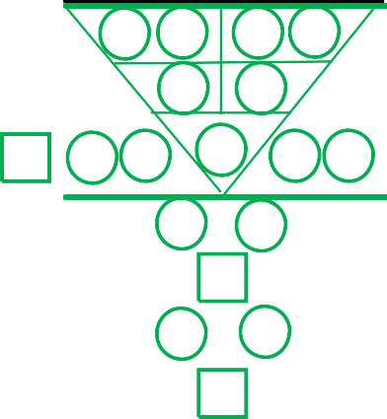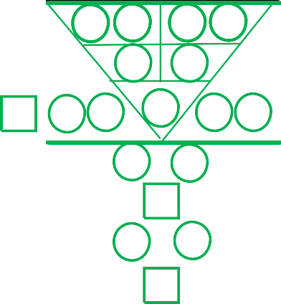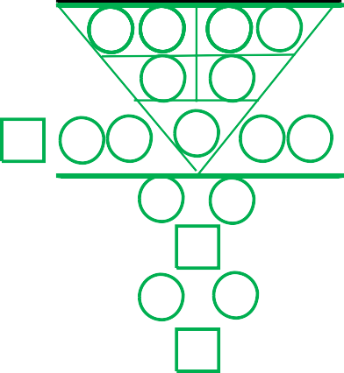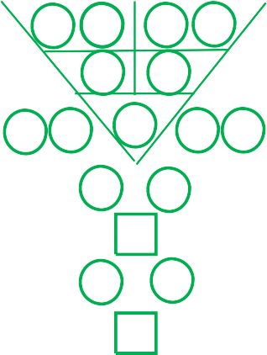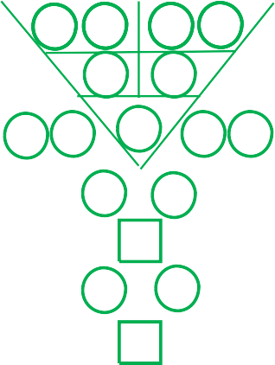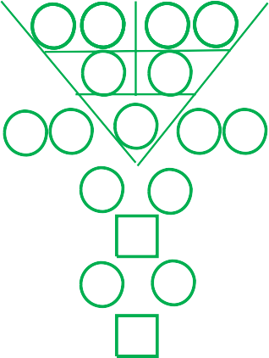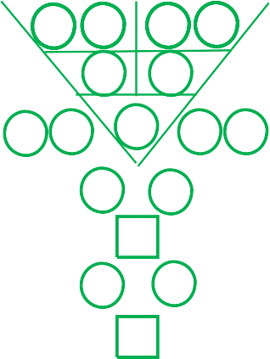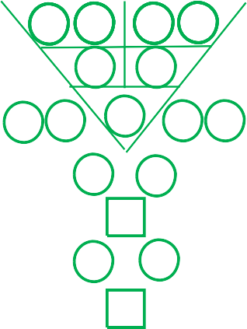

6

9

9

3

9

9

**9 years personal outlook for Kiran Shetty**

**Year Year Year**

|  |  |  |  |  |  |  |  |  |  |
| --- | --- | --- | --- | --- | --- | --- | --- | --- | --- |
|  | |  | | | 2 | | 0 | 2 | 2 |
| 0 | 8 | 0 3 | | | 2 0 | | | 2 2 | |
|  | 8 | | 3 |  | | 4 | 8 | |  |
|  |  | | 2 |  | | 3 |  | |  |
| 1 | 5 | |  | 5 | |  | 7 | | 2 |
| 8 | | | |  | | 7 | | | |
|  | | | | 6 | |  | | | |
| 4 | | | |  | | 5 | | | |
|  | | | | 9 | |  | | | |
|  | | | | | | | | | |

|  |  |  |  |  |  |  |  |  |  |
| --- | --- | --- | --- | --- | --- | --- | --- | --- | --- |
|  | |  | | | 2 | | 0 | 2 | 3 |
| 0 | 8 | 0 3 | | | 2 0 | | | 2 2 | |
|  | 8 | | 3 |  | | 4 | 9 | |  |
|  |  | | 2 |  | | 4 |  | |  |
| 1 | 5 | |  | 6 | |  | 8 | | 4 |
| 1 | | | |  | | 8 | | | |
|  | | | | 9 | |  | | | |
| 8 | | | |  | | 1 | | | |
|  | | | | 9 | |  | | | |
|  | | | | | | | | | |

|  |  |  |  |  |  |  |  |  |  |
| --- | --- | --- | --- | --- | --- | --- | --- | --- | --- |
|  | |  | | | 2 0 | | | 2 | 4 |
| 0 | 8 | 0 3 | | | 2 0 | | | 2 2 | |
|  | 8 | | 3 |  | | 4 | 1 | |  |
|  |  | | 2 |  | | 5 |  | |  |
| 1 | 5 | |  | 7 | |  | 9 | | 6 |
|  |  | | 3 |  | | 9 |  | |  |
|  |  | |  | 3 | |  |  | |  |
|  |  | | 3 |  | | 6 |  | |  |
|  |  | |  | 9 | |  |  | |  |
|  | | | | | | | | | |

6

6

9

6

3

6

**Year**

|  |  |  |  |  |  |  |  |  |  |
| --- | --- | --- | --- | --- | --- | --- | --- | --- | --- |
|  | |  | | | 2 | | 0 | 2 | 5 |
| 0 | 8 | 0 3 | | | 2 0 | | | 2 2 | |
|  | 8 | | 3 |  | | 4 | 2 | |  |
|  |  | | 2 |  | | 6 |  | |  |
| 1 | 5 | |  | 8 | |  | 1 | | 8 |
| 5 | | | |  | | 1 | | | |
|  | | | | 6 | |  | | | |
| 7 | | | |  | | 2 | | | |
|  | | | | 9 | |  | | | |
|  | | | | | | | | | |

**Year**

|  |  |  |  |  |  |  |  |  |  |
| --- | --- | --- | --- | --- | --- | --- | --- | --- | --- |
|  | |  | | | 2 | | 0 | 2 | 6 |
| 0 | 8 | 0 3 | | | 2 0 | | | 2 2 | |
|  | 8 | | 3 |  | | 4 | 3 | |  |
|  |  | | 2 |  | | 7 |  | |  |
| 1 | 5 | |  | 9 | |  | 2 | | 1 |
| 7 | | | |  | | 2 | | | |
|  | | | | 9 | |  | | | |
| 2 | | | |  | | 7 | | | |
|  | | | | 9 | |  | | | |
|  | | | | | | | | | |

**Year**

|  |  |  |  |  |  |  |  |  |  |
| --- | --- | --- | --- | --- | --- | --- | --- | --- | --- |
|  | |  | | | 2 0 | | | 2 | 7 |
| 0 | 8 | 0 3 | | | 2 0 | | | 2 2 | |
|  | 8 | | 3 |  | | 4 | 4 | |  |
|  |  | | 2 |  | | 8 |  | |  |
| 1 | 5 | |  | 1 | |  | 3 | | 3 |
|  |  | | 9 |  | | 3 |  | |  |
|  |  | |  | 3 | |  |  | |  |
|  |  | | 6 |  | | 3 |  | |  |
|  |  | |  | 9 | |  |  | |  |
|  | | | | | | | | | |

6

6

9

6

3

6

**Year**

|  |  |  |  |  |  |  |  |  |  |
| --- | --- | --- | --- | --- | --- | --- | --- | --- | --- |
|  | |  | | | 2 | | 0 | 2 | 8 |
| 0 | 8 | 0 3 | | | 2 0 | | | 2 2 | |
|  | 8 | | 3 |  | | 4 | 5 | |  |
|  |  | | 2 |  | | 9 |  | |  |
| 1 | 5 | |  | 2 | |  | 4 | | 5 |
| 2 | | | |  | | 4 | | | |
|  | | | | 6 | |  | | | |
| 1 | | | |  | | 8 | | | |
|  | | | | 9 | |  | | | |
|  | | | | | | | | | |

**Year**

|  |  |  |  |  |  |  |  |  |  |
| --- | --- | --- | --- | --- | --- | --- | --- | --- | --- |
|  | |  | | | 2 | | 0 | 2 | 9 |
| 0 | 8 | 0 3 | | | 2 0 | | | 2 2 | |
|  | 8 | | 3 |  | | 4 | 6 | |  |
|  |  | | 2 |  | | 1 |  | |  |
| 1 | 5 | |  | 3 | |  | 5 | | 7 |
| 4 | | | |  | | 5 | | | |
|  | | | | 9 | |  | | | |
| 5 | | | |  | | 4 | | | |
|  | | | | 9 | |  | | | |
|  | | | | | | | | | |

**Year**

|  |  |  |  |  |  |  |  |  |  |
| --- | --- | --- | --- | --- | --- | --- | --- | --- | --- |
|  | |  | | | 2 0 | | | 3 | 0 |
| 0 | 8 | 0 3 | | | 2 0 | | | 2 2 | |
|  | 8 | | 3 |  | | 4 | 7 | |  |
|  |  | | 2 |  | | 2 |  | |  |
| 1 | 5 | |  | 4 | |  | 6 | | 9 |
|  |  | | 6 |  | | 6 |  | |  |
|  |  | |  | 3 | |  |  | |  |
|  |  | | 9 |  | | 9 |  | |  |
|  |  | |  | 9 | |  |  | |  |
|  | | | | | | | | | |

**2 0 3 0**

**2 0 2 9**

**2 0 2 8**

**2 0 2 7**

**2 0 2 6**

**2 0 2 5**

**2 0 2 4**

**2 0 2 3**

**2 0 2 2**



6

6

9

6

3

6

**THE CLARITY OF D'LIFE JOURNEY**

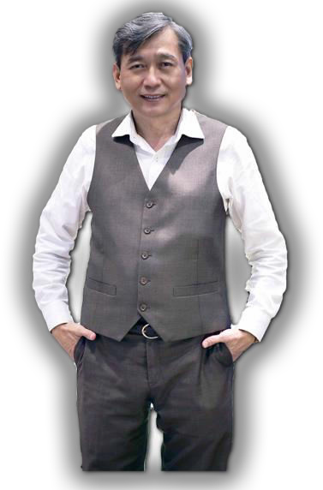

Clarity of the mind and heart are the keys to empower you to make the right decisions to predict and prevent challenges in all your future life journey.

~ Dr Bernard Yeo, Hon PhD

Dr Bernard Yeo is a researcher and the founder of the Universal Characteristic Method of Human Profiling (UCMHP) and World’s 1st Character Coach. He has spent more than 12 years engaged in deep intensive studies of human behaviour, their personalities and character traits.

He has personally analysed more than 15,000 individuals’birth numbers, stemming across diverse cultures, genders and backgrounds.

In the year 2012, Dr Bernard Yeo received the Asia Pacific Outstanding Business Professional Award for his pioneer work and contributions to the field of applied science character profiling. He was subsequently conferred in 2013 the Honorary Doctor of Philosophy in Human Capital Development and Human Profiling in recognition for his outstanding researched.

Dr Bernard Yeo continues to dig deeper into the mystery’sinsight of the clarity of human psyche and to share his discoveries with the world.

##### UCMHP Academy Pte Ltd

**3 Irving Road, #01-09, Tai Seng Centre Singapore 369522**

**Tel: (65) 6748 6279 Email:** [**cs@ucmhpacademy.com**](mailto:cs@ucmhpacademy.com)

[**www.ucmhpacademy.com**](http://www.ucmhpacademy.com/) **Facebook:** [**www.facebook.com/UCMHP**](http://www.facebook.com/UCMHP)

Copyright © 2012 UCMHP Academy Pte Ltd, All Rights Reserved. Update 2021

**®**